- Home page
Intro
Headline: Your Trusted Sourcing partner in China (revise).
We Make Things Easier for you by Finding a reliable supplier and ensuring smooth production and delivery. Our team manages every step, from product selection and supplier verification to on-time delivery.

Make this line straight in the design (to me it doesn’t look good)
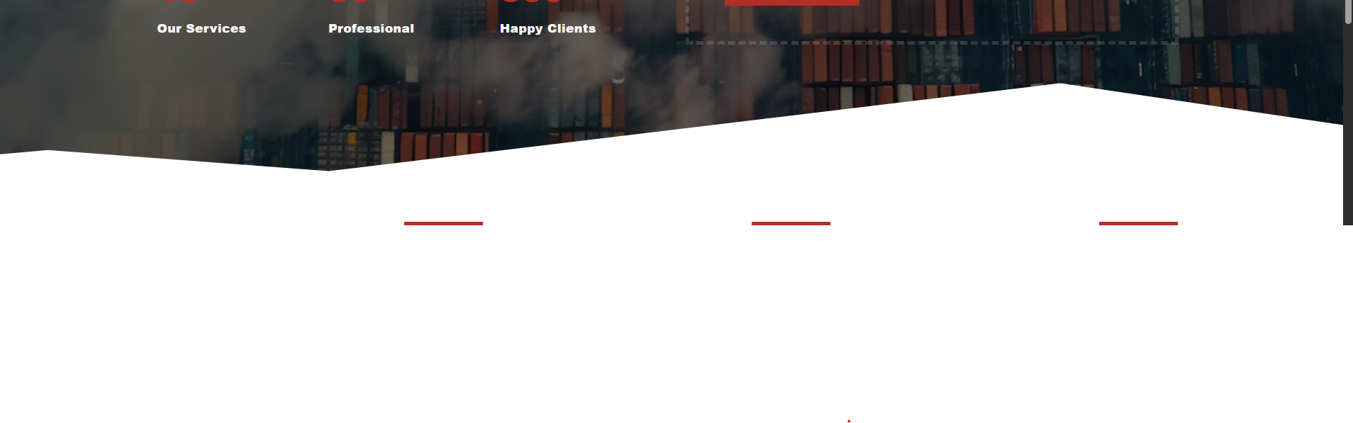
This intro part should be before the SOLUTIONS given in next screenshot THIS Has DONE)
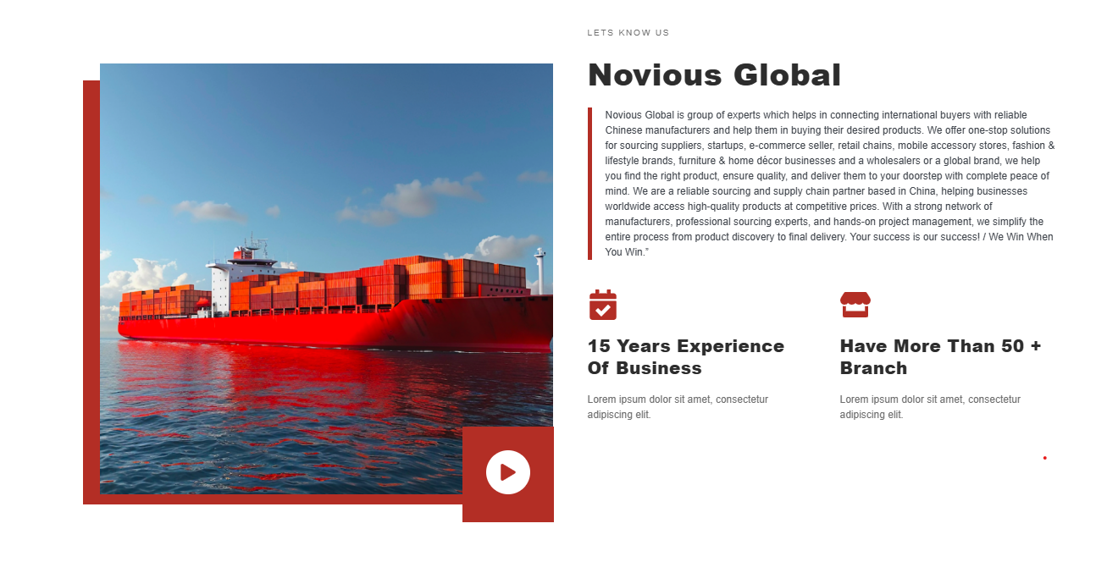
Have More Than 30 supplier & Manufactures
Extensive product sourcing through a broad network of reliable manufacturers
9 Years of Experience of Business
Product sourcing, Project Based Services, Quality Inspection, Dropshiping etc.
Intro Content: (revise)
Novious Global, located in Shanghai, provides end-to-end sourcing solutions, enabling global buyers to connect with dependable Chinese manufacturers and purchase quality products with confidence. Our diverse team of foreigners and Chinese experts brings together exceptional communication, business insight, and cross-cultural understanding. We offer one-stop solutions for sourcing suppliers, startups, e-commerce seller, retail chains, mobile accessory stores, fashion & lifestyle brands, furniture & home décor businesses and a wholesalers or a global brand, we help you find the right product, ensure quality, and deliver them to your doorstep with complete peace of mind. We are helping businesses worldwide access high-quality products at competitive prices. With a strong network of manufacturers, professional sourcing experts, and hands-on project management, we simplify the entire process from product discovery to final delivery.
Your success is our success!

NOTE:
1- red color hasn’t changes even though after reminding for several times
2- Check the shapes (text boxes) are in consistent in terms size and color combinations (even the text)
3- Partners logos
4-

What We Do
This looks great design wise but I think this is taking too much space. Is it possible if you can add only two slides moving from right to left (as arrows indicating the slides movement).
1- Good
2- Move content in tab 2 to 3, and 3 to 2 (as arrow shows). (DID YOU DO THIS)?

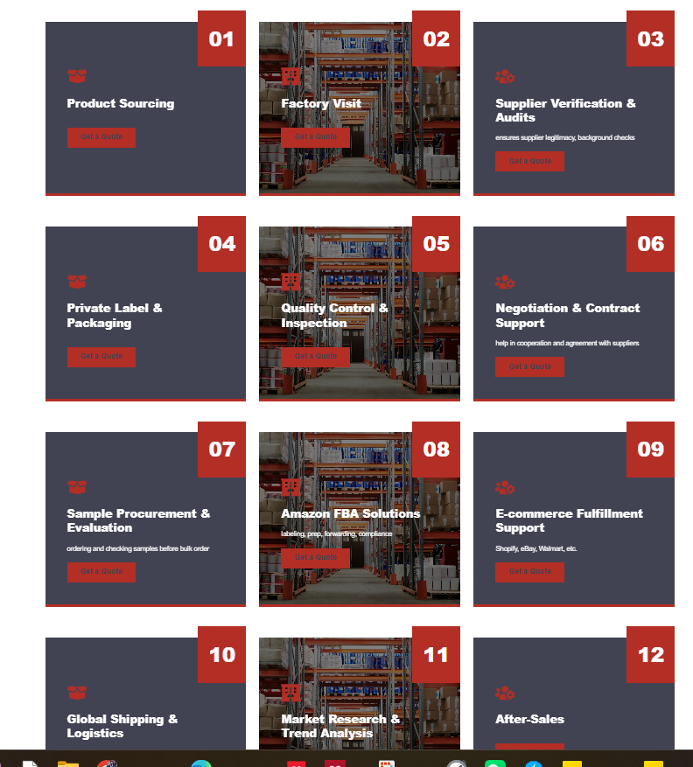
Can the both slides move together
This whole space will be free, so we can add other introductory content
Slide move
Slide move

OR this way without sides movement (what we do)

Product Sourcing (keywords: (supplier selection, contract review, and quality control, risk mitigation)

(
Quality Control & Inspection
Product quality inspection and Pre-shipment inspection etc.

Private Label & Packaging
Logo printing and branding, Custom product development

Factory Visit &
Supplier Verification
Manufacturer verification and Supplier background research

E-commerce Fulfillment Support
Shopify, Amazon, WHATNOT, eBay and WooCommerce order fulfillment for
online sellers

Amazon FBA Solutions
Shipping to Amazon warehouses (China to US/EU/UK) and FBA supplier management

Negotiation & Contract Support
Identifying negotiation objectives (price, MOQ, lead time, delivery, warranty, quality, etc.)

Global Shipping & Logistics
Shipping route planning (sea, air, rail, express) Incoterms negotiation (FOB, TTP, CIF, EXW, DDP, etc.)

How We Work
Understand Your Product/Project Needs
We start by discussing your end goals, style preferences, budget, and material needs, creating a tailored product/project plan to meet your expectations.

Source Factories & Provide Quotations
We identify and verify the most suitable factories, and provide transparent quotations for key materials such as garments, shoes, and lighting etc.

Supervise Production & Track Progress
We closely monitor production to ensure timely completion and provide regular updates to keep you informed of the progress.

Factory Visits, Negotiation & Contracts
We arrange factory visits to evaluate production capabilities and sample quality, negotiate prices, production time, delivery time etc. and finalize contracts.

Inspect Goods & Arrange Shipping
We conduct pre-shipping quality inspection, Freight booking, Shipment scheduling, Export documentation (Invoice, Packing List, B/L), Cost and time optimization in logistics

Below boxe shapes are not aligned, move the No 4 and No 5 in the middle of above (No 1,2,3)
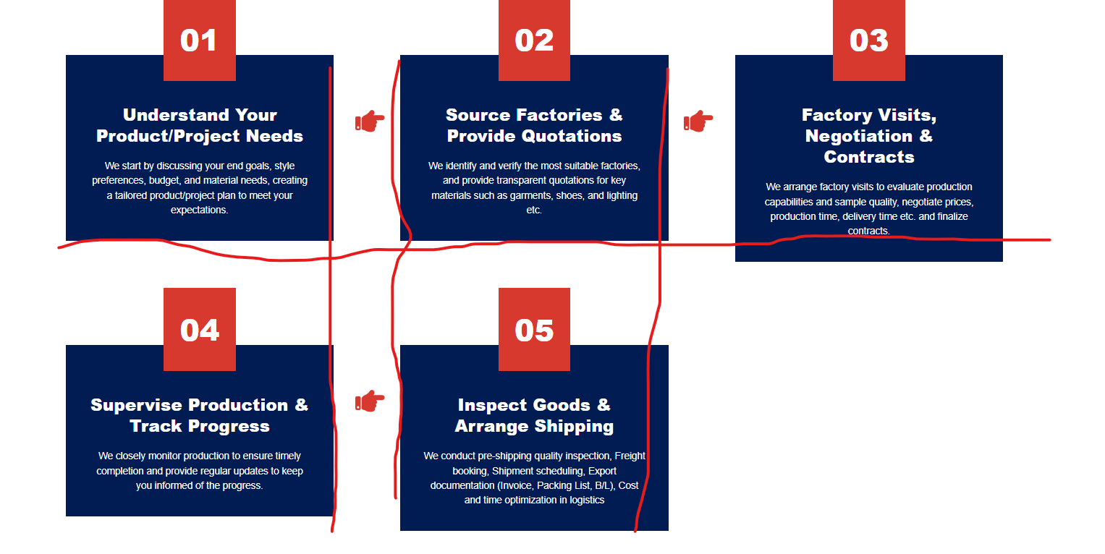

We Have Committed to Perfect Work for Get Perfect Product Sourcing Services


Why Choose Us (reference for below image)
The Best Product Sourcing Services in China for You
- Have 50 + Branch Office
Extensive Network in China as we have access to reliable companies across multiple industries, with full understanding Chinese business environment.

- 9 Years Experience Business
Proven experience and expertise in handling diverse and complex projects for international clients.
- End-to-End Solutions
The sourcing solution and agreements to logistics and supervision, we cover the sourcing entire process.
- Trustworthy Partner
A reliable partner for global businesses, offering transparent sourcing, accountable operations, and long-term cooperation. We prioritize clients’ needs with a client-first approach, ensuring quality, consistency, and dependable supply chain solutions.

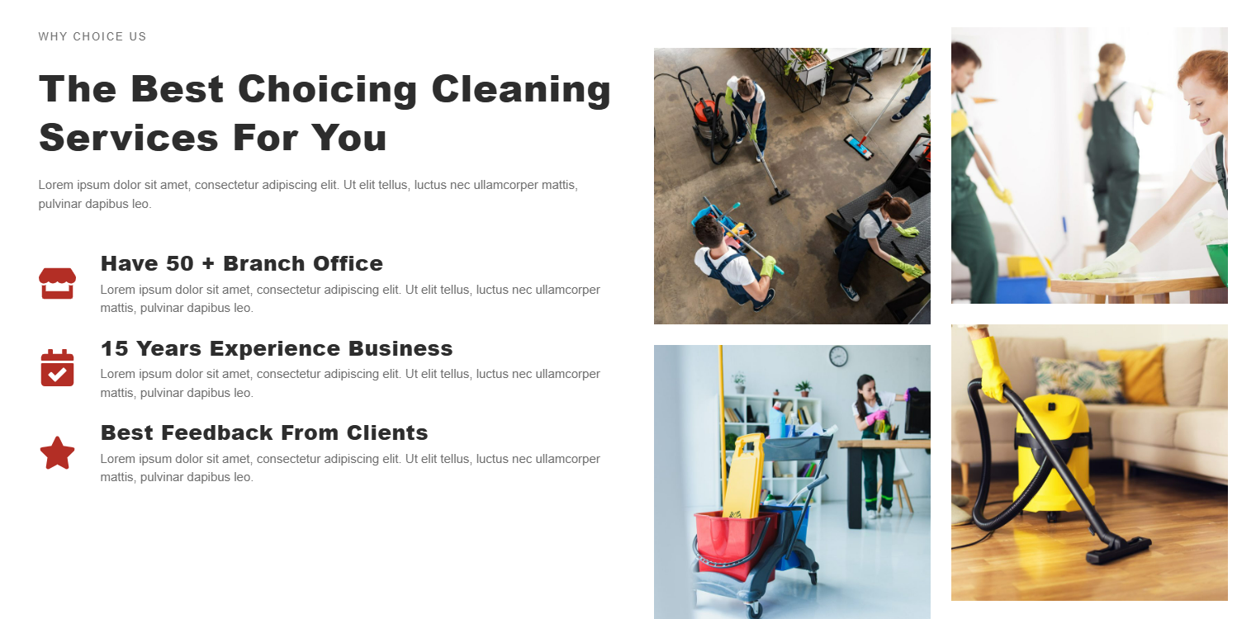

Package
Note: The prices shown are indicative; the final quotation will be provided after fully understanding your requirements.
Starter Pack E-Commerce Sourcing All in One Project Base Service

- Initial meeting to understand project needs
- Provide visa invitation (if required)
- Accompany clients to visit suppliers
- Identify suitable factories
- Conduct factory visits
- Assist in meetings with suppliers
- Support price negotiation and contract finalization
- End-to-end project management: production, quality control, shipment, and delivery
- Post-project support and follow-up

- Initial meeting to understand Product/Project needs
- Product/ Market research
- Supplier identification & verification
- Factory Visit
- Provide Quotations
- Negotiation & Contracts
- Lead times, Payment Terms
- Supervise Production & Track Inspect Goods
- Pre-shipping inspection
- Shipping arrangements
- Sourcing Strategy
- Consultancy

- Product sourcing from verified manufacturers
- Supplier/vendor outreach and identification
- Quotation collection and comparison
- Price negotiation support
- Basic sourcing consultancy
- Sample coordination and review
- Product sourcing
- Supplier/vendor verification
- Price negotiation and MOQ management
- Quotation collection
- Cost optimization
- Sample inspection and quality check
- Packaging and labeling
- Shipping arrangement

- Bold the headings of each package
- Link each package to WhatsApp

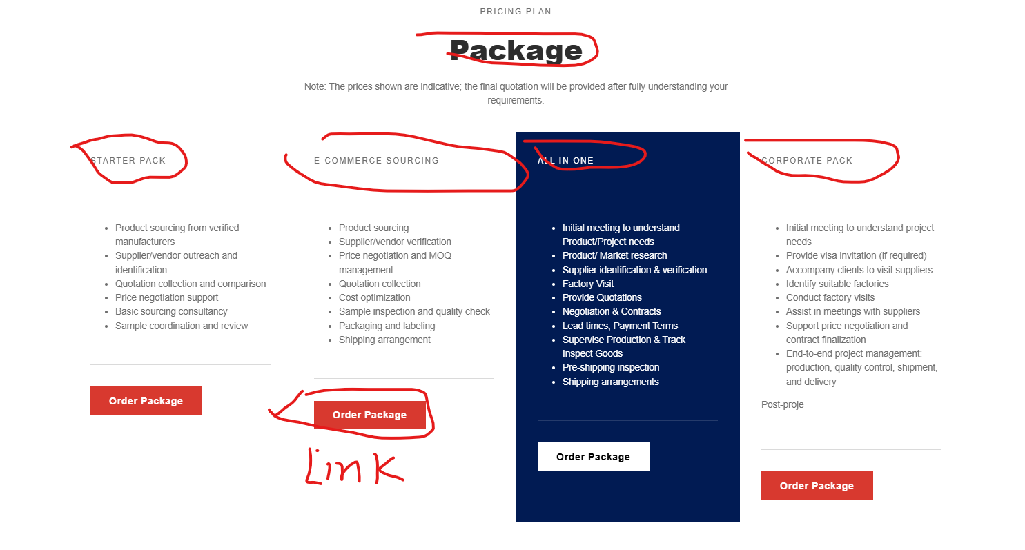

Partners (images will be provided later) (this hasn’t done even after sending the logos of our partners)
4
3
2
1

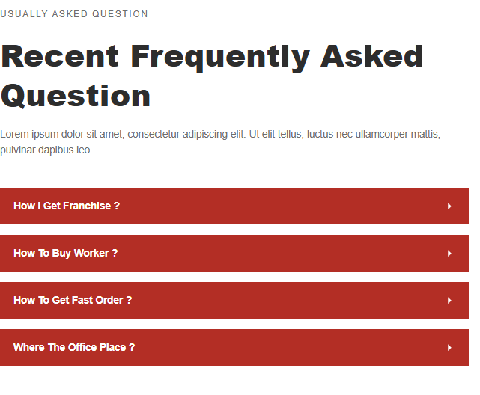
1. What services do you offer for product sourcing?
We provide end-to-end product sourcing services, including supplier identification, factory verification, quotation collection, price negotiation, sample coordination, and quality inspection to help businesses source reliable products from China and other markets.
2. How do you ensure the quality of products from suppliers?
Our team performs pre-shipment inspections, in-process quality checks, and factory audits to ensure that every product meets your quality standards. We also assist in sample review and compliance verification before mass production.
3. Can you help with Amazon FBA or e-commerce fulfillment?
Yes! We offer specialized FBA and e-commerce solutions, including product sourcing, supplier verification, packaging and labeling guidance, shipping to Amazon warehouses, and logistics coordination to help online sellers streamline their operations.
4. Do you provide support for large or project-based sourcing?
Absolutely. Our Project-Based Services include personalized consultations, factory visits, supplier meetings, contract support, price negotiation, and end-to-end project management, ensuring smooth execution from production to shipment.
5. How do I get a quotation for my sourcing requirements?
You can share your project details with us through our contact form or consultation call. Once we understand your requirements, we provide a transparent quotation tailored to your product specifications, quantity, and sourcing complexity.

Our Clients Feedback
John Peterson – CEO, Global Sports Co.
Working with Novious globe’s team has transformed our sourcing process. They identified reliable factories, helped with price negotiations, and ensured every product met our quality standards. Their hands-on approach made importing from China seamless and stress-free.
Hassam Ijaz – CEO REEM Fashion
The Novious global sourcing expertise in supplier verification and product sourcing was exceptional. Their professionalism and attention to detail made them a trusted partner for our fashion line.
Maria Gonzalez – Founder, EcoHome Supplies
The FBA and e-commerce support we received from Novious sourcing was outstanding. From sourcing to packaging and shipping, every step was professionally handled. Thanks to their guidance, our products reached Amazon warehouses on time and in perfect condition.
Liam Zhang – Operations Manager, BrightTech Solutions
We engaged them for a project-based service and were impressed with their level of detail. They accompanied us on factory visits, helped finalize contracts, and managed production and shipment efficiently. Truly a trustworthy partner for international sourcing.

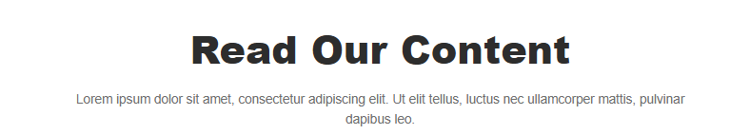
Sourcing with Trust & Transparency| Quality Without Compromise| Client Success First| Local Expertise, Global Vision| Commitment to Long-Term Partnerships| Responsiveness
I did not ask you just to insert the text there but meaning is to show the blogs slide down here)
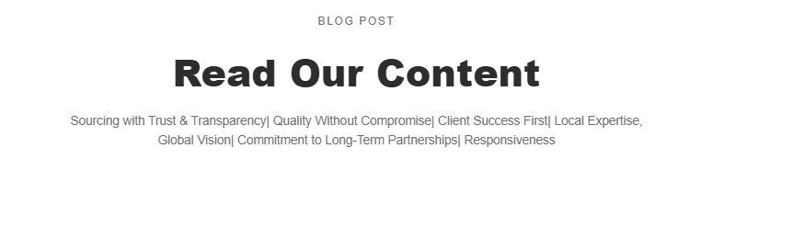

2- Products Preview Page (Clickable Categories something like below in image)
（4-6 Images of different products from each category and a short product description）
Products category preview

Products Content: Follow (https://jingsourcing.com/our-products/)

Customizable

OEM/ODM Available

1 by 1 Quality Inspection

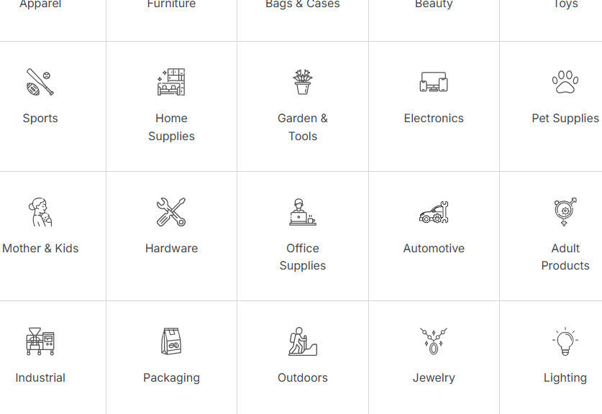
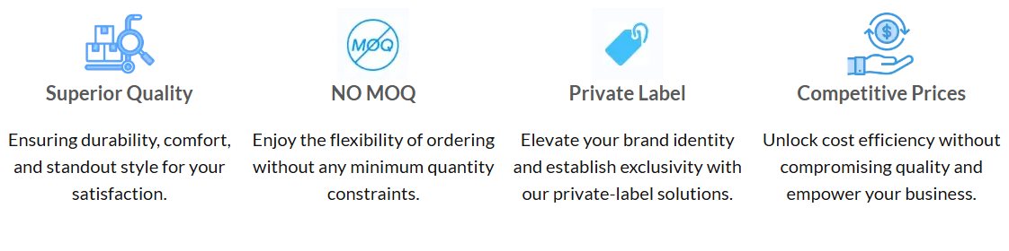

Add: However, some of the products require MOQ (add in every page)

2.1-Clothing, Textile
China is a global leader in apparel manufacturing, offering trendy clothing, scarves, hats, and fashion accessories sourced from trusted suppliers. We provide custom logo printing, embroidery, and pattern design with low MOQs and factory-direct prices. Choose from a wide range of ready-to-ship garments tailored to your market demand.
Whether you need ready-made or fully customized products, we deliver flexible sourcing solutions tailored to your brand and market needs.

Link this call us now to open a query form or direct to whatsapp
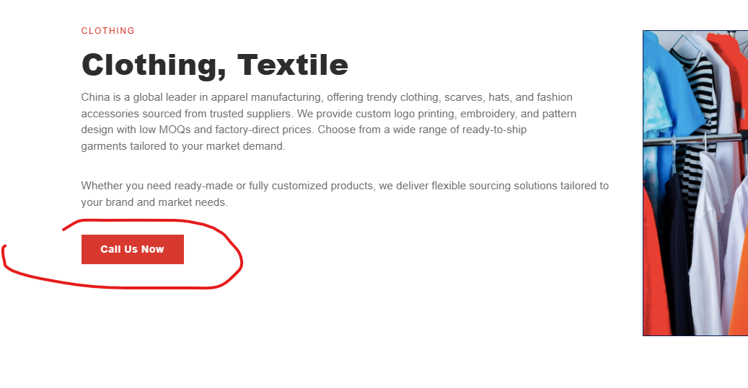
Add this query form below each product catagory (didn’t you notice from the reference website?) https://jingsourcing.com/our-products/apparel-sourcing/
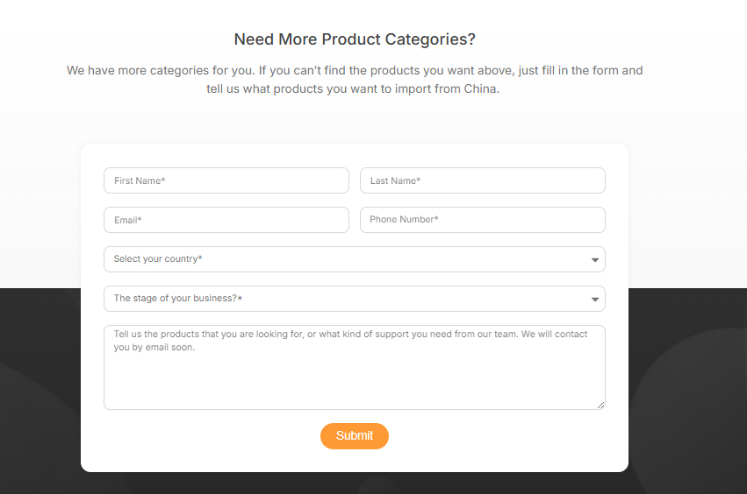

Apparel
As the world’s largest clothing producer, China manufactures nearly 60% of global apparel, offering exceptional variety and quality. We source and customize a full range of fashion and workers uniform, including jackets, coats, sportswear, stage outfits, work uniforms, leather jeans, vests, undershirts, polo shirts, casual tops, sweaters, hoodies, long and short skirts, high heels, trousers, denim jeans, T-shirts, and dresses for both men and women.
We also offer different kinds of clothing in stock at factory-direct prices.

1.2 Baby & Kid’s Products
Safe and reliable children’s clothing, educational toys, and accessories—all compliant with international safety standards
Padel Kids short sleeve T-shirt, Children's clothing sets
Autumn cotton long-sleeve, Summer slip dress
Winter children's down jacket autumn jacket, Brand children's clothing factory

Socks
We help you find several sock factories even with a low MOQ (only $500). You can get the latest styles like traditional knitted styles or custom 3D-printed ones from us.
Jackets, Coats, Jeans, T-shirts, Shirts, Sweaters and Hoodies, Skirts, Vests, Children's Winter Down Jackets, Undershirts and Tops, Lace Blouses and Chiffon Shirts, Women's Overalls and Bodysuits, Fur Coats, Baseball Jackets, Trenches and Raincoats

Undergarments
We’re experienced in producing and designing types of undergarments in diverse fabrics. No matter seamless fabric, daily wear, or sexy style, we help you wholesale or customize any you want.

T-shirts, Shirts, Polo shirts, Henley shirts, Sweatshirts, Hoodies, Tank tops, Sweaters, Pullovers, Cardigans, Jackets, Coats, Vests, Blazers, Jeans, Trousers, Casual pants, Chinos, Shorts, Sweatpants, Joggers, Leather jackets, Denim jackets, Windbreakers, Parkas, Down jackets, Raincoats, Tracksuits, Sports shorts, Compression shirts, Suits, Dress shirts, Dress pants, Waistcoats, Swimwear, Thermal wear, Belts, Scarves, Gloves, Hats
Women Special
Long Skirt
Short Skirt
Underwear
Underpants
High Heels
Yoga Clothing
Swimwear
Sexy Apparel
Yoga Pants
Thermal Underwear
Pajamas
Athletic Undergarment
Fashionable
Medical Clothing
Medical Clothing
Muslim Clothing
Leather jackets
Fur coats
Clothing for pregnant women
Women's overalls and body
Sexy thin supporting nail
Sexy push up bra
Trousers, retro jeans

2.1- Fashion Accessories
Stylish Fashion Accessories for Every Occasion!
We help you wholesale and customize all kinds of clothing accessories, like gloves, hats, belts, scarves, watches, sunglasses, ties, pins, belts, etc. Tell us what you need if you can’t find them in the list.
- Men

Headwear, Belts & Footwear Accessories
- Hats (caps, beanies, fedoras)
- Scarves
- Gloves
- Belts / Suspenders
- Socks
- Shoe laces / Insoles / Shoe care kits

Watches & Jewelry
- Watches
- Bracelets
- Rings
- Necklaces / Chains
- Cufflinks
- Lapel pins

Bags & Carry Essentials
- Wallets
- Sun Glasses
- Messenger bags
- Backpacks
- Briefcases
- Travel bags / Duffel bags
- Keychains

Women
We provide a wide range of footwear, fashion accessories, and bags, sourcing high-quality products directly from trusted manufacturers. Our sourcing strategy focuses on partnering with reliable factories to ensure consistent quality, diverse styles, and competitive pricing. Our offerings include men’s, women’s, and children’s footwear, as well as jewelry such as necklaces, earrings, bracelets, rings, anklets, hair jewelry, watches, and brooches.

Headwear, Scarves & Fashion Extras
- Hats (sun hats, berets, fedoras, caps)
- Sun Glasses
- Fascinators / Hair combs
- Hair clips / Barrettes
- Headbands
- Hair ties / Scrunchies
- Hairpins / Bobby pins
- Scarves / Shawls
- Face masks (fashionable)
- Gloves (fashionable or evening gloves)
- Belts / Waist chains / Sashes / Ribbons
- Shoe clips / Decorative shoe laces / Heel chains / Charms
- Umbrellas (fashionable)
- Sunglasses / Eyewear chains
- Ties / Cravats (fashion use)
- Leg garters (fashion use)

Jewelry & Watches
- Necklaces (chains, chokers, pendants)
- Earrings (studs, hoops, dangly, ear cuffs)
- Bracelets / Bangles / Cuffs
- Rings
- Anklets
- Hair jewelry / Tiaras
- Watches
- Brooches / Pins

Bags & Carry Essentials
- Handbags
- Backpacks
- Travel Bags
- Toiletry Bags
- Makeup Bag
- Crossbody bags
- Backpacks
- Wallets / Purses
- Tote bags
- Kid Bag
- Phone charms / Accessories
- Keychains (decorative)



2.2 Shoes for Everyone
Our sourcing strategy focuses on providing a wide range of high-quality footwear for men, women, and children by partnering directly with trusted manufacturers. We prioritize reliable production, consistent quality, and diverse styles, ensuring competitive pricing and timely delivery to meet the demands of global markets.
Men Women Kids
We provide infants and toddlers (0–4 years) soft-soled shoes, baby booties, pre-walker shoes, crib shoes, slip-on shoes, sandals, water shoes, baby sneakers, baby slippers, baby dress shoes; preschool and school-age children (5–12 years) sneakers, running shoes, athletic shoes, flip-flops, slide sandals, boots, snow boots, rain boots, hiking boots, dress shoes, school uniform shoes, loafers, flats, ballet flats, clogs, water sandals; and teens (13+ years) sneakers, running shoes, athletic shoes, sandals, flip-flops, slide sandals, boots, snow boots, rain boots, hiking boots, dress shoes, loafers, flats, clogs, water shoes, water sandals, high-top sneakers, platform shoes, and casual shoes.
We provide Flats, Slip-On Shoes, Sneakers, Running Shoes, Heels, Kitten Heels, Stilettos, Block Heels, Pumps, Wedges, Ankle Boots, Knee-High Boots, Over-the-Knee Boots, Chelsea Boots, Dress Boots, Casual Boots, Sandals, Slide Sandals, Gladiator Sandals, Wedge Sandals, Flip-Flops, Espadrilles, Clogs, Slippers, Indoor Slippers, Dance Shoes, Ballet Shoes, Winter Boots, Snow Boots, Rain Boots, Hiking Boots, Waterproof Shoes, Breathable Shoes, Lightweight Shoes
We provide men’s sneakers, loafers, casual shoes, boots, sandals, formal shoes, slippers, sports shoes, running shoes, hiking shoes, work boots, outdoor shoes, water shoes, boat shoes, snow boots, safety shoes, dress shoes, trail running shoes, cross-training shoes, tennis shoes, soccer cleats, golf shoes, cycling shoes, skate shoes, wrestling shoes, and waterproof boots.


2.3 Bags & Cases
Our bag collection offers styles for every need. Handbags and tote bags are perfect for daily use, while backpacks and messenger bags provide convenient carrying options for work or school. Clutch bags suit formal occasions, wallets keep money and cards organized, and laptop bags protect your devices. Diaper bags help parents carry essentials, and travel bags, including luggage and carry-ons, ensure easy and organized journeys.
Travel & Specialty Bags
Backpacks
Diaper Bags
Travel Bags
Luggage
Sports Bags

Work & Tech Bags
Laptop Bags
Messenger Bags
Briefcases
Everyday & Fashion Bags
Handbags
Tote Bags
Clutch Bags
Crossbody Bags
Wallets


2.4 Electronics

We source high-quality electronics for vloggers, podcasters, and content creators, including Audio video, equipment such as laptops, tablets, external drives, microphones, audio interfaces, mixers, cameras, tripods, and essential accessories. Our products ensure professional audio, video, and streaming solutions, making content creation easy, reliable, and efficient for Live Sound Card - Audio Interface for Laptop Computer Vlog Living Broadcast Live Streaming.
Consumer electronics, mobile accessories, and reliable products tested for safety and efficiency.
Audio, Video & Wearables
Bluetooth Headsets / / Earbuds
Earphones
Screen Protectors & Cases
Power Banks
Chargers & Cables
Speakers (Bluetooth, Home, Portable)
Home Theater Systems
Projectors & Screens
Soundbars
Microphones & Recording Equipment
Streaming Devices

Computers & Accessories
Laptops / Notebooks
Desktops / All-in-One PCs
Monitors
Keyboards & Mice
External Storage (HDD, SSD, Flash Drives)
RAM / Graphics Cards / Motherboards
Printers & Scanners
Webcams & Microphones

Home Appliances & Smart Devices
fan
Water Dispenser
Hair Dryer
Security Cameras / CCTV
Smart Lights / Bulbs
Vacuum Cleaners (Robot & Manual)
Air Purifiers / Humidifiers

Vloggers, podcasters, and content creators
Podcast Equipment
DSLR/Mirrorless Cameras
Podcast equipment bundle
Headphones
Action Cameras: GoPro Hero 13 Black, DJI Osmo Pocket 3
Lighting
Boom Arms
Webcams: Logitech C920 HD Pro
Webcams: Logitech C920 HD Pro
Rotolight Ultimate Vlogging Kit
USB Microphones
UM6 XLR podcast Microphones
Portable Recorders
Gimbal Stabilizers: DJI Osmo Mobile 4
Portable Lighting
Shock Mounts
Drone Cameras & more


Pictures
2.5 Kitchen
Discover a wide range of cookware, kitchen utensils, and innovative gadgets designed to make cooking easier and more enjoyable. From pots, pans, knives, cutting boards, and measuring tools to modern kitchen gadgets like blenders, food processors, peelers, and multi-functional tools, we offer high-quality products that bring convenience, efficiency, and style to households worldwide.



2.6 Furniture
We source a wide range of indoor and outdoor furniture, offering modern, functional, and customizable solutions to meet diverse market needs. Our sourcing strategy focuses on partnering with trusted manufacturers to provide high-quality sofas, chairs, tables, beds, cabinets, wardrobes, outdoor seating, patio sets, garden furniture, and modular solutions. Each piece can be tailored in terms of materials, finishes, colors, and sizes to match client requirements, ensuring both style and durability. By leveraging our extensive network of reliable suppliers, we deliver cost-effective, on-trend furniture that combines aesthetic appeal with practicality, catering to retailers, e-commerce businesses, and interior designers worldwide.

- Outdoor Furniture
- Home Furniture
- Office Furniture
- Kid's Furniture
- Bathroom Furniture
- Bedroom Side Table
- Luxury Garden Furniture
- Aluminum Table
- Sunbed
- Teak Sofa


2.7 Sports & Entertainment
We source a wide range of sports and entertainment products from verified suppliers, ensuring quality, reliability, and competitive pricing. Our offerings include sporting goods for football, basketball, tennis, golf, swimming, gymnastics, hockey, padel, baseball, cricket, badminton, boxing, and cycling, as well as outdoor gear such as camping, hiking, and fitness equipment.
Sport Equipment and Products Project
We provide end-to-end sourcing solutions for sports projects, delivering high-quality equipment, infrastructure, and materials directly from trusted manufacturers. From designing and setting up padel courts, basketball courts, and football fields to supplying sports gear for gyms, schools, and clubs, we ensure every element meets international standards. Our services include vendor selection, factory verification, quality inspection, logistics coordination, and on-time delivery, making your sports project efficient, reliable, and cost-effective.
Tennis Rackets, tennis balls, nets, grips, wristbands, shoes, racquet bags, ball hoppers.
Football/Soccer balls, goalposts, nets, shin guards, cleats, training cones, goalkeeper gloves, jerseys, whistles.
Golf clubs (drivers, irons, putters), golf balls, tees, golf bags, gloves, rangefinders, club headcovers, practice nets.
Swimwear, goggles, swim caps, kickboards, pull buoys, fins, snorkels, swim paddles, waterproof bags.
Gymnastics balance beams, vaulting tables, uneven bars, rings, mats, pommel horses, parallel bars, springboards, grips.
Hockey sticks, pucks/balls, goals, protective gear (helmets, shin guards, gloves).
Padel rackets, padel balls, nets, court markings, ball baskets, shoes designed for padel.
Basketballs, hoops, nets, backboards, sneakers, training cones, shot clocks, scoreboards.
Baseball Bats, balls, gloves/mitts, helmets, bases, catcher's gear, pitching machines, batting tees, cleats.
Cricket Bats, balls, stumps, protective pads, gloves, helmets, wickets, cricket nets, shoes/spikes.
Badminton Rackets, shuttlecocks, nets, posts, grips, shoes, birdie tubes, court mats.
Boxing gloves, punching bags, speed bags, hand wraps, headgear, mouthguards, boxing ring, jump ropes, focus mitts.
Bicycles (road, mountain, hybrid), helmets, gloves, cycling shoes, water bottles, bike lights, locks, repair kits, saddles, pedals.



2.8 Lights & Lighting (https://tinasourcing.com/products/lights-sourcing/)
We source a wide range of lights and lighting solutions, including LED lights, decorative fixtures, and smart lighting, designed to brighten indoor and outdoor spaces with style, efficiency, and reliability.
Decorative & Specialty Lighting LED strip lights, fairy lights, color-changing RGB lights, neon lights, decorative lamps, artistic lamps, mood lights, projector lights, lava lamps.
Professional & Industrial Lighting Stage lights, studio lights, photography lights, ring lights, spotlights, track lights, high bay lights, warehouse lights, workshop lights.
Smart & Energy-Efficient Lighting
Smart bulbs, smart strips, smart panels, energy-saving LED bulbs, motion-activated lights, dimmable lights, solar-powered lights.

Outdoor Lighting
Floodlights, wall lights, garden lights, pathway lights, post lights, solar lights, security lights, string lights, landscape lights, motion sensor lights.
Indoor Lighting
Ceiling lights, chandeliers, pendant lights, flush mount lights, wall sconces, table lamps, floor lamps, under-cabinet lights, track lighting, recessed lights, vanity lights, night lights, LED panels.



2.9 Energy Solution & Batteries
Consumer electronics, mobile accessories, and reliable battery solutions tested for safety and efficiency. Surveillance cameras, ultrasound, thermometers, lab equipment, EVs, scooters, lithium batteries, BMS, charger’s Solar panels, PV cells, inverters, solar kits.
Products Project Solution
We provide comprehensive solutions for energy projects, offering mobile power systems, residential and commercial energy storage solutions, and EV charging stations. Our services extend to BESS (Battery Energy Storage Systems) as all-in-one solutions for industrial and commercial applications. We manage the entire process, including supplier selection, factory verification, quality control, certifications, testing reports, contracts, warranty management, and price negotiation, ensuring reliable, high-quality energy solutions delivered on time. We have a network of trusted industry partners available to support our projects.
Lithium Cells (prismatic, Cylindrical, Pouch for E-Bikes etc)
Lithium-ion Batteries
Solid State Batteries
Lead-acid Batteries
Rechargeable Batteries
Inverters
Power Banks
Battery Packs
Portable Generators
UPS (Uninterruptible Power Supply) Systems
Energy Storage Systems
Battery Management Systems (BMS)
Marine Battery System
Battery Cabinets & Enclosures
Battery Testing Equipment



2.10 Bathroom Essentials
Explore a complete range of bathroom products, including towels, bath mats, shower accessories, storage solutions, organizers, soap dispensers, and other daily essentials designed for comfort, functionality, and style. Perfect for creating a well-organized, relaxing, and modern bathroom space.
Products Project Solution
We provide end-to-end sourcing solutions for bathroom construction projects, supplying high-quality towels, bath mats, shower accessories, storage solutions, organizers, soap dispensers, and other daily essentials directly from trusted manufacturers. Our services cover supplier verification, quality inspection, contract negotiation, logistics management, and timely delivery, ensuring every bathroom is functional, stylish, and completed to specification. Whether for residential, commercial, or hospitality projects, we streamline the entire process to meet project timelines and quality standards.
• Towels
• Bath Mats
• Shower Curtains
• Shower Caddies & Organizers
• Soap Dispensers
• Toothbrush Holders
• Bathroom Storage Cabinets
• Shelves & Racks
• Laundry Baskets
• Toilet Paper Holders
• Towel Racks & Hooks
• Bathroom Mirrors
• Bathroom Accessories Sets
• Bathrobes
• Shower Benches & Stools



2.11 Home Décor & Accessories
Discover a curated collection of decorative pieces, wall art, lighting accents, vases, sculptures, clocks, and household accessories that bring style, personality, and warmth to every living space. Perfect for creating a modern, cozy, and elegant home environment.
Pillow
Towel
Toothbrush
Toothbrush Cup
Blanket
Storage Box
Bedding set
Sponge Mop
Absorbent Blanket
Bedroom Door Mat
Clocks & Wall Décor
Home Textiles (Cushions, Throws, Rugs, Curtains)


2.12 Hardware Tools
We provide a wide range of high-quality hand tools, power tools, and DIY kits suitable for both industrial and household use. Our selection includes essential hand tools like screwdrivers, hammers, wrenches, saws, and hand drills, as well as industrial machinery and machine tools for precision manufacturing. Whether you’re a professional tradesperson or a DIY enthusiast, our tools are sourced directly from trusted manufacturers to ensure reliability, durability, and performance.
🏭 Industrial Machinery / Machine Tools
Pipe Benders
Punch Presses
Calipers
Micrometers
Cranes
Pallet Jacks
Material Handling Carts
Rotators
Packaging Machines
Labeling Machines
Weighing Scales
Polishing Machines
Deburring Machines
Grinding Machines

⚙️ Power Tools
Cordless Drills
Hammer Drills
Impact Drivers
Rotary Hammers
Angle Drills
Screw Guns
Cordless Screwdrivers
Cutting Tools
Circular Saws, Jigsaws
Table Saws
Band Saws
Angle Grinders
Oscillating Multi-Tools

🛠️ Hand Tools
Claw Hammer
Ball Peen Hammer
Screwdrivers (Flathead, Phillips)
Pliers (Needle Nose, Slip-Joint, Locking)
Wrenches (Adjustable, Combination, Pipe)
Utility Knives
Tape Measures
Levels (Spirit, Laser)
Chisels (Woodworking, Cold)
Hand Saws (Panel, Hacksaw, Coping)
Hammers (Claw, Sledge, Rubber Mallet)
Pipe Benders
Bolt Cutters
Measuring & Layout Tools



2.13 Toys
Our sourcing strategy focuses on working with trusted manufacturers to provide high-quality, safe, and innovative toys that cater to every age group and market demand, from infants to teens.

Outdoor & Sports Toys such as Bicycles, scooters, skateboards, balls, water toys, trampolines, swings, and slides.

Action & Figurines such as superhero figures, dolls, playsets, collectible figurines, and action toys.

Educational Toys such as Puzzles, building blocks, STEM kits, learning tablets, alphabet and number toys, art and craft kits.

Creative & Role Play Toys: Costume sets, kitchen playsets, tool sets, pretend play kits, and musical instruments.

Electronic & Interactive Toys like remote-controlled cars, drones, robots, electronic pets, and interactive learning toys.

Baby & Toddler Toys like Soft toys, rattles, teething toys, play gyms, activity centers, stacking toys, and walkers.
Games & Puzzles: Board games, card games, strategy games, and 3D puzzles.

3. Services Page (https://foreasyhome.com/how-we-work/)
1- Souring similar to this page (https://worryfree360.com/one-stop-sourcing/)
One-Stop Sourcing
We simplify the complexity of global trade. From finding suppliers and negotiating prices to managing quality and logistics, Novious Global provides an end-to-end sourcing service.
Supplier Verification
We supplier/manufacturer visits, meeting, negotiation, product quality inspections, certifications checks, and supplier background verification to minimize risks.
Product Development Support
Need a unique design or private label? We help in private labeling and assists in product development, customization and prototyping.
Warehousing & Consolidation
Short-term storage and consolidation services for multiple orders before shipment.
Trade Show & Market Guidance
We actively participate in China and global trade fairs and exhibitions, providing first-hand access to emerging products.
Add Separator (same page)
3.1- Solution
- Product sourcing (https://jingsourcing.com/pricing/)
Product Sourcing
We find the most reliable manufacturers for your needs—balancing price, quality, and delivery time. (Similar to JingSourcing Pricing)
Private Label & Packaging Solutions
We help you customize your products with branding, packaging design, and labeling to stand out in your market.
Fast & Secure Global Shipping
From express courier to sea freight, we handle the logistics to deliver your products safely, cost-effectively, and on time.
Amazon FBA Solutions
Specialized support for Amazon sellers: direct delivery to Amazon warehouses, packaging compliance, and product preparation.
Quality Control & Inspection
Every order is checked before shipment—covering raw materials, production process, and final inspection to ensure top quality.

4. Project Base Service page

Your Trusted Ambassador in China — Building Partnerships That Last

Introduction
We provide end-to-end project-based services for international corporations and investors seeking reliable partnerships in China. Whether you are wishing to pursue long-term cooperation or short-term contracts, we help you connect, negotiate, and build successful relationships with the right partners. With deep market knowledge, a trusted network, and proven experience, we make complex projects simple, seamless and efficient.

Project Categories
We can assist you in a wide variety of projects, including:
- Energy Solutions: Solar power plants, residential energy solution, commercial energy solution, wind farms, hydro projects, and EV charging station networks.
- Infrastructure Development: Roads, bridges, industrial complexes, and urban facilities.
- Sports & Recreational Facilities: Padel courts, football fields, gyms, and swimming pools.
- Specialized Industrial Projects: Factories machines, equipment’s, warehouses, technology parks.
- Electronics and Machinery: Electric bike, Motor bike Flood lights, etc.
- Telecom
- Medical & Hospital Equipment

How We Add Value
Our strength lies in bridging international businesses with trusted Chinese companies through:
- Product & Supplier Sourcing connecting you with the right partners for your project.
- Supplier Management by ensuring reliable cooperation with vetted and verified companies.
- Construction & Project Support by coordinating local execution while aligning with global standards.
- Quality Control & Inspection Safeguarding project quality through rigorous checks.
- Logistics & Global Shipping by managing transport, customs, and timely delivery.
- Project Supervision by overseeing milestones to ensure smooth execution and accountability.

How it works:
We begin with a brief consultation to understand your objectives, whether it’s a strategic partnership, cooperation, or appointing an exclusive sales partner. From there, we help identify the right partner, arrange meetings, assist with negotiations and translations, formalize agreements, and provide ongoing support throughout the buying process

- Consultation Understanding your project goals and requirements.
- Partner Identification Leveraging our network, and capability to connect you with the right companies in China.
- Negotiation & Agreement Supporting you in establishing fair, transparent, and secure contracts.
- Execution & Oversight Coordinating suppliers, quality control, inspections, logistics.
- Delivery & Ongoing Support Ensuring your project is completed successfully, with post-project assistance available.

Why Choose Us
- Extensive Network in China as we have access to reliable companies across multiple industries, with full understanding Chinese business environment.
- End-to-End Solutions from sourcing and agreements to logistics and supervision, we cover the entire process.
- Proven Experience and expertise in handling diverse, complex projects for international clients.
- Trustworthy Partner A client-first approach built on transparency, accountability, and long-term cooperation.

5. Business Strategy
Digital & Business Strategy for Chinese Businesses Going Global

Digital Strategy & Brand Building
We empower Chinese manufacturers, exporters, and entrepreneurs to go global with confidence. As both strategic advisor and hands-on implementer, we deliver a dual-pronged approach: a modern digital strategy plus a robust business strategy. In today’s world, having a global footprint means engaging billions online over 5.56 billion people use the internet. We leverage this connectivity to boost your brand and sales overseas. Whether you’re a manufacturer, trader, or building a personal brand, our services are tailored to your needs.
Strategic Digital Solutions to Expand Beyond Borders
Our digital strategy is built to put your brand at the center of the global market. We design and develop localized websites that showcase your products to international audiences, supported by a cohesive brand identity. We optimize SEO and content to ensure discoverability 73% of online experiences begin with a search engine. We also leverage targeted Google Ads and powerful social platforms: TikTok alone has 1.59 billion monthly users worldwide, while networks like Facebook, LinkedIn and Instagram help you connect with professional and consumer communities across regions. Our key digital service offerings include:
SEO & Content Marketing Keyword optimization and content creation. Since most customers start their search online, we optimize your website and content to rank highly in Google and other international search engines.
Social Media Strategy
Facebook
Instagram
Tiktok
Youtube Channel
Website Development
& Branding
Global-ready websites and consistent brand design. We ensure your site is multi-language, mobile-responsive, and reflects a modern global brand image.

Analytics & Optimization Data-driven insights and continuous improvement. We track user behavior, sales performance, and campaign ROI to refine your strategy over time, maximizing your return on investment.
Social Media & Community Engagement on platforms like TikTok, LinkedIn, Facebook, and Instagram. We create campaign content and communities. For example, TikTok campaigns can tap into niche communities worldwide, rapidly increasing awareness of your brand overseas.
Paid Ad Campaigns
Google Ads
Mata Ads
Tiktok
LinkedIn
We target high-potential markets with data-driven ads (by region, language, and interest) to drive qualified traffic and leads.

Business Strategy
Our business strategy services lay the groundwork for successful international expansion. We help Chinese companies find and vet the right overseas partners, whether distributors, agents, or joint ventures to extend your reach. By combining market data with local know-how, we help you break down geographical barriers and navigate unfamiliar markets confidently. We assist with every step of the cooperation process (contracts, negotiation, compliance, logistics) to ensure a smooth market entry. Finally, we provide sales training and development, equipping your team with the skills to negotiate and sell in foreign markets effectively. Key business strategy services include:
Partner Sourcing & Alliances
Identify and connect with reliable international distributors, retailers, or joint-venture partners. Our research-driven approach and networks help bridge distances and establish strong business relationships.
Market Entry & Compliance
End-to-end support for entering new markets. We conduct market research, advise on legal and regulatory requirements, and handle logistics and documentation so you can focus on growth.
Sales Training & Development
Train your sales force in global selling techniques. We cover cross-cultural communication, export sales strategies, sales pitch, and negotiation skills so that your team can convert international leads into loyal customers.

Our Partner in digital Partner
Ingenious concepts
Ingenious concepts

6-Blog Page

7. About Us Page
Reference: https://worryfree360.com/about-us/
Heading: Your Trusted Sourcing Partner​​ in China
About Founder & CEO
Meet Our Founder: Mr. Hamid
About Our Founder
Hamid is the visionary founder behind our company, with over eight years of experience working directly with Chinese manufacturers across industries including consumer goods, garments, fashion accessories, energy, electronics, hardware, and construction. He learned Chinese language to develop a strong communication skill to broaden his network and deep understanding of China business environment. Further, he completed his Master’s degree in International Trade and PhD in Business Management from Shanghai China. His unique blend of cross-cultural expertise, business knowledge, and hands-on industry experience enables him to build strong partnerships and deliver effective business solutions in the global market.
Hamid has helped numerous international clients establish reliable partnerships, manage projects, and source high-quality products efficiently. Fluent in Chinese and familiar with local business culture, he bridges communication and cultural gaps to ensure smooth sourcing.
He recognized the common challenges in supplier verification, quality control, and logistics, for foreigners. Thus, Hamid founded this company in 2022 to provide a transparent, trustworthy, and efficient sourcing model connecting global buyers with verified Chinese manufacturers and suppliers.
Hamid’s vision and leadership
Hamid leads with a hands-on approach and a strong belief that trust and transparency are the foundation of lasting partnerships. Under his leadership, our company culture is built around reliability, attention to detail, and personalized service. Hamid remains actively involved in daily operations, ensuring that every client receives dedicated attention and professional guidance. His vision continues to drive our mission to make sourcing from China accessible, easy, reliable, and successful for businesses worldwide.

Our Story​​
Our story began in 2022 when Hamid, the founder of Novious Global, recognized a growing need for reliable and transparent sourcing solutions in China. Having experienced firsthand the challenges faced by international buyers which are the language barriers, supplier identification and verification, quality inconsistencies, and logistical hurdles. He set out to build a company that would serve as a true partner for businesses worldwide. With a strong belief in integrity and client success, Hamid assembled a team of skilled professionals both foreigners and Chinese who shared his vision. Together, we built Novious Global on the principles of trust, quality, and end-to-end support. Today, we proudly help hundreds of clients streamline their sourcing process, reduce risks, and achieve their business goals. Your success is our greatest motivation, and we're committed to growing alongside you.
​ Our Story in Numbers
Since our founding in 2022, we take pride in the significant milestones we've reached while serving clients worldwide:
​​1000+ Satisfied Clients Globally​​ – Building trust across 30+ countries.
​​98% Client Retention Rate​​ – A testament to our reliable, quality-driven service.
​​Successfully Handled 1000+ Orders​​ – From sourcing to delivery, seamlessly.
​​Strategic Partnerships with 150+ Verified Suppliers​​ – Ensuring quality and competitive pricing.
​​​​These accomplishments reflect our dedication to being your trusted sourcing partner in China. Your trust drives us; your success defines us.
​​ ​
Join Our Growing Family of International Clients​​
Whether you're a startup, e-commerce seller, or established brand, Novious Global is here to make your China sourcing journey worry-free. Let us be your partners in growth and success. Your vision, sourced by us. Let's build something great together.
​​Ready to experience stress-free sourcing from China? ​​
​​Contact us today to start your journey! ​​

​​ 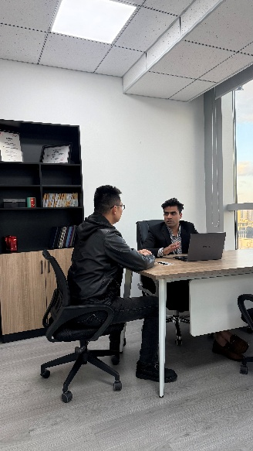 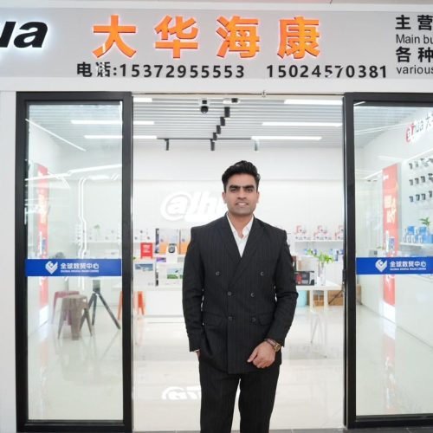 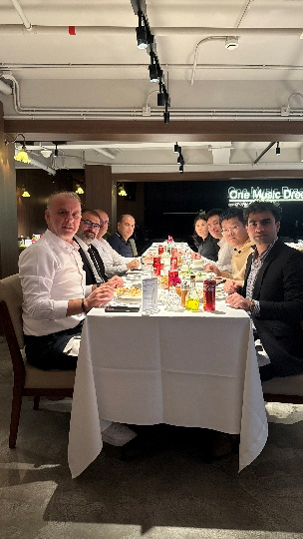

8-Contact Page

📍Address: ​​Head Office: ​​ Lotus Tower, No. 150 Tianzhou Road, Shanghai 200032, China
📧 ​​Email: ​​ info@noviousglobal.com
📞 ​​Phone: ​​ +86 15618483542
💬 ​​WhatsApp: ​​ +923077433743
🌐 ​​Web: ​​ noviousglobal.com

Social Media accounts for integration
Youtube: https://www.youtube.com/@NoviousGlobal
Instagram: https://www.instagram.com/chinasourcing_?igsh=OHN0NXdpNGxpcTBq&utm_source=qr
Facebook: https://www.facebook.com/noviousglobalsourcingchina
TikTok: www.tiktok.com/@novious.global.china
LinkedIn: https://www.linkedin.com/company/novious-global-sourcing-from-china/

